1) Create a image from running container.
Step 1: Run a container
docker run -it ubuntu bash
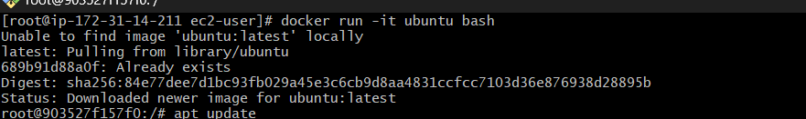
Install something inside:
apt update
apt install nginx -y
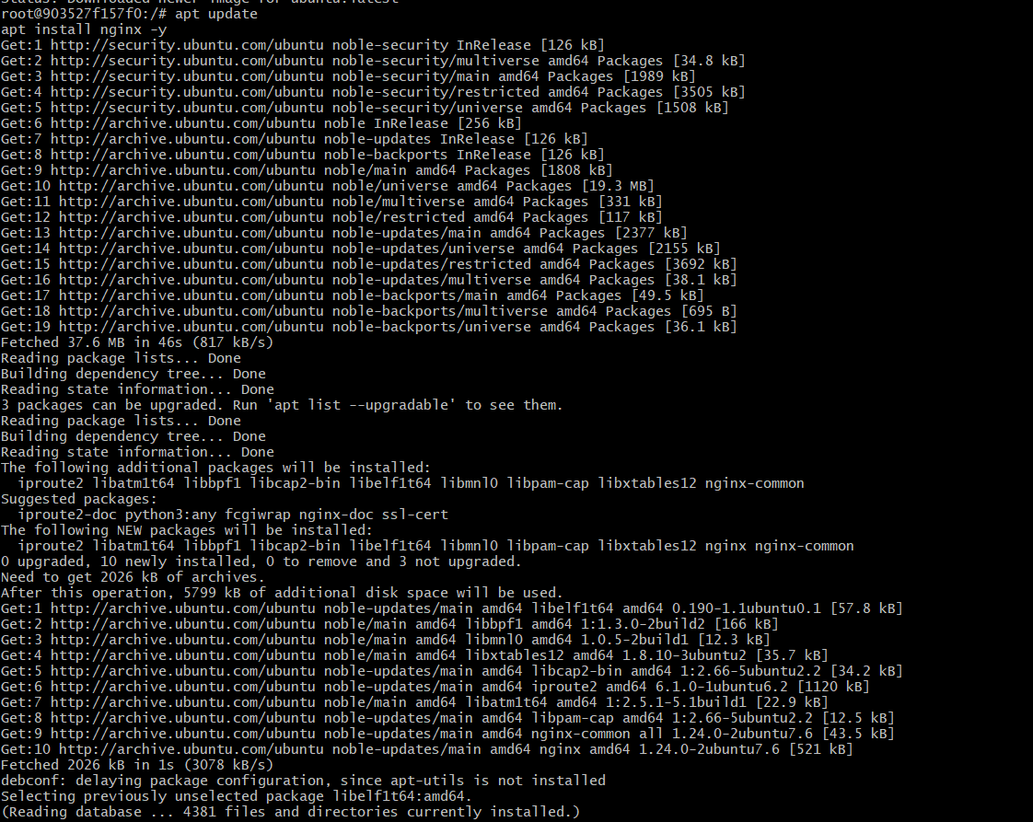
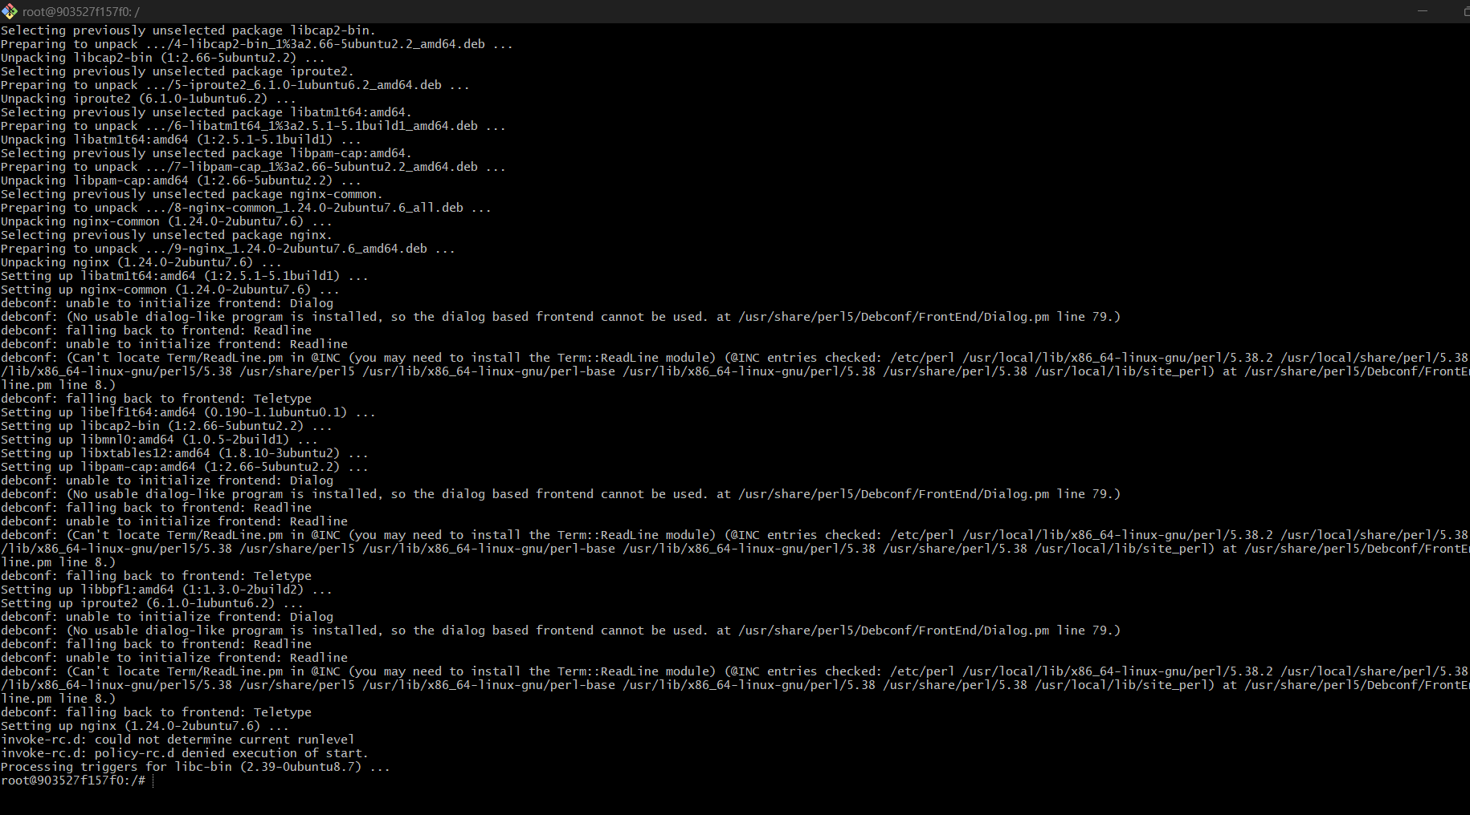
Exit:
exit
Step 2: Check container ID
docker ps -a
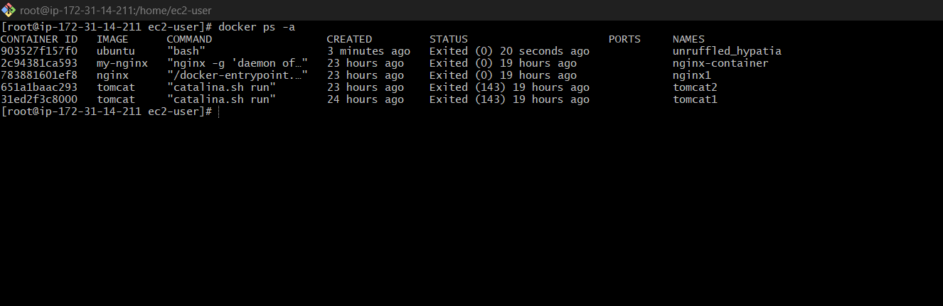

Step 3: Create image from container
docker commit <container_id> my-nginx-image
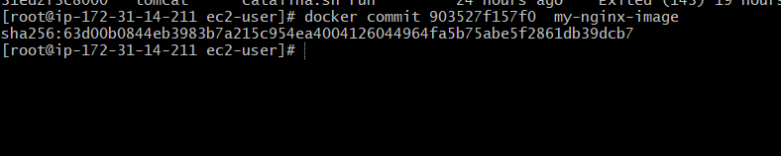

Explanation:
- docker commit = snapshot of running container
- Creates reusable image

2) Copy image from local machine to docker server and load the image.

Step 1: Save image
docker save -o myimage.tar my-nginx-image
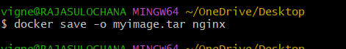

STEP 2: Copy to /tmp
Run from your local:
scp -i /c/Users/vigne/Downloads/docker.pem myimage.tar ec2-user@13.48.129.38:/tmp/
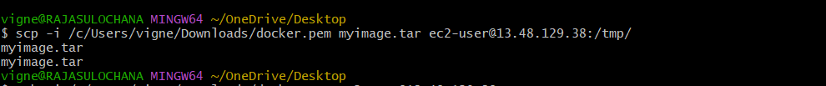

STEP 3: Login to EC2
ssh -i /c/Users/vigne/Downloads/docker.pem ec2-user@13.48.129.38
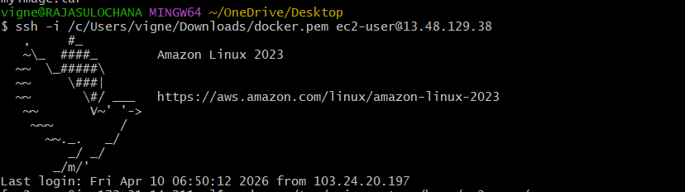

STEP 4: Verify File
ls /tmp

You should see:
myimage.tar
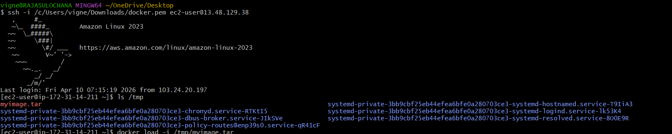

STEP 5: Load Docker Image
docker load -i /tmp/myimage.tar

Expected Output
Loaded image: nginx:latest
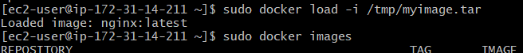

STEP 5: Verify Image
docker images
Confirm:
nginx latest
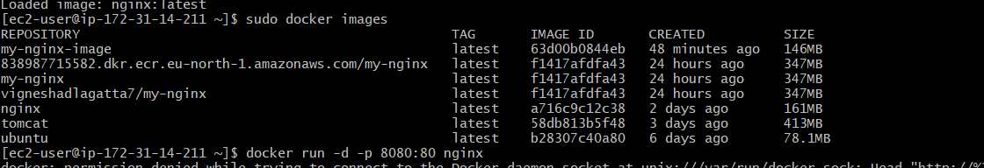

STEP 6: Run Container
docker run -d -p 8080:80 nginx

STEP 7: Check Running Container
docker ps
You should see container running

STEP 8: Access Application
Open browser:
http://13.48.129.38:8080
Nginx welcome page will appear

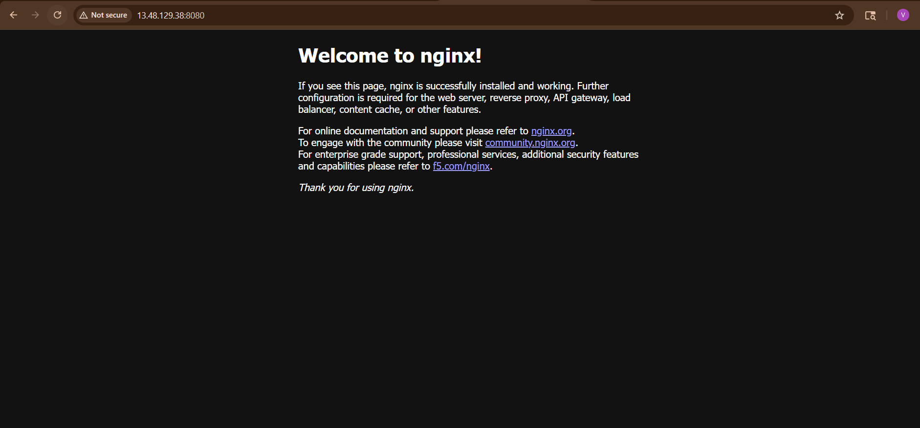

3)Create Docker image using alpine and customize with tomcat.

STEP 1: Create Project Folder
mkdir tomcat-alpine
cd tomcat-alpine
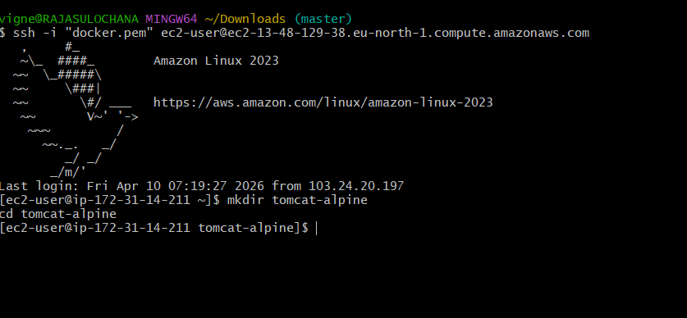

STEP 2: Create Dockerfile
vi Dockerfile

Paste this:

FROM alpine:latest
LABEL maintainer="Vignesh"
RUN apk update && \
apk add openjdk8 wget tar && \
wget https://archive.apache.org/dist/tomcat/tomcat-9/v9.0.65/bin/apache-tomcat-9.0.65.tar.gz && \
tar -xvf apache-tomcat-9.0.65.tar.gz && \
mv apache-tomcat-9.0.65 /tomcat
EXPOSE 8080
CMD ["/tomcat/bin/catalina.sh", "run"]

:wq

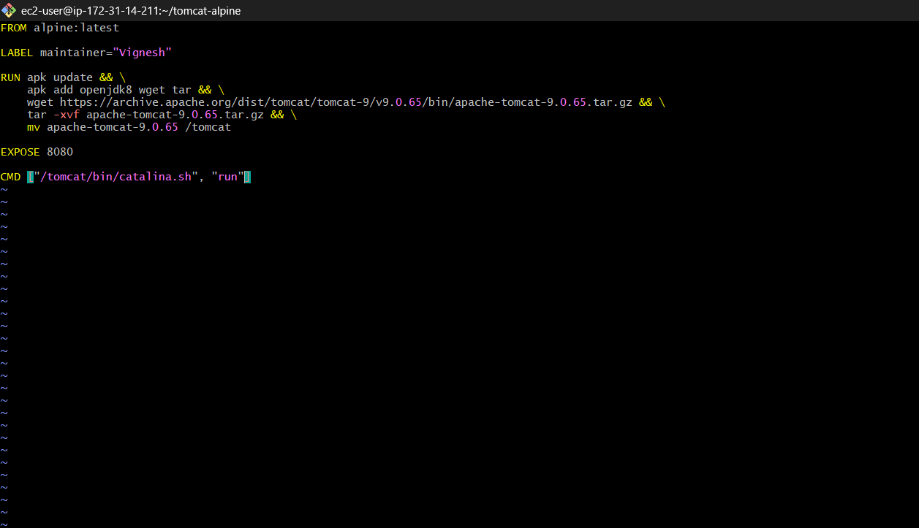

STEP 3: Understand Dockerfile (Simple)
- FROM alpine → lightweight OS
- apk add → install Java + tools
- wget → download Tomcat
- tar → extract
- EXPOSE 8080 → app port
- CMD → start Tomcat

STEP 4: Build Docker Image
docker build -t tomcat-alpine .
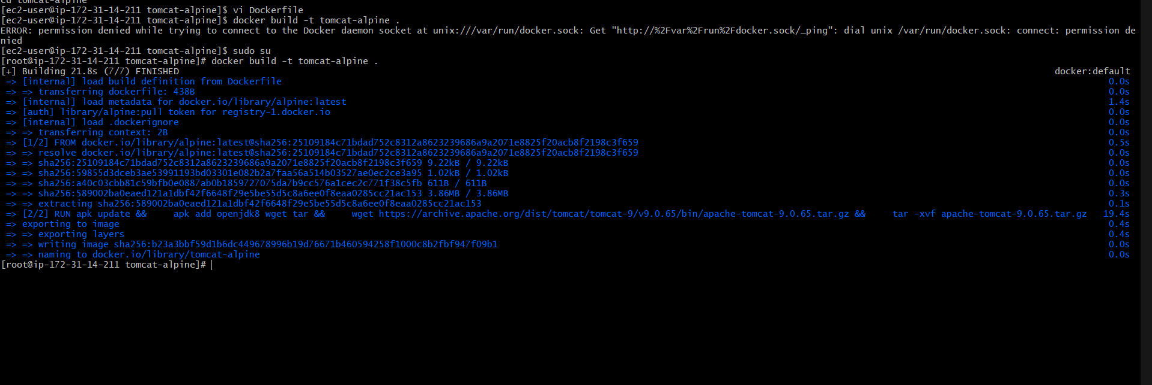
-t = tag (image name)

STEP 5: Verify Image
docker images
You should see:
tomcat-alpine latest
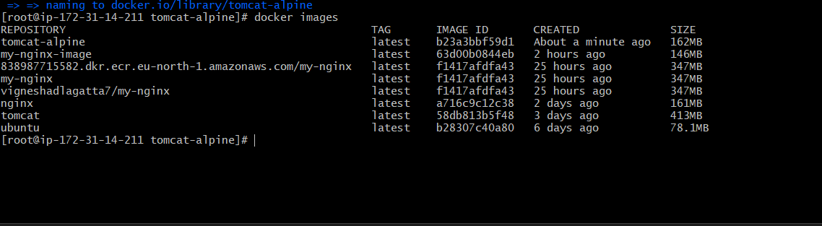

STEP 6: Run Container
docker run -d -p 8081:8080 tomcat-alpine
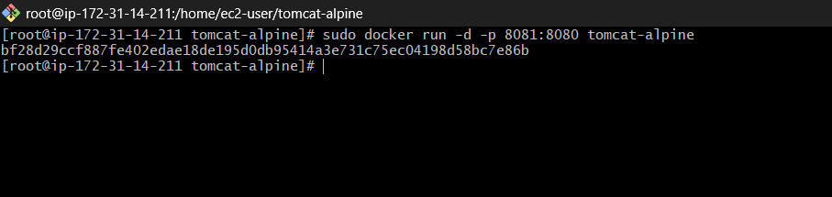

STEP 7: Check Container
docker ps

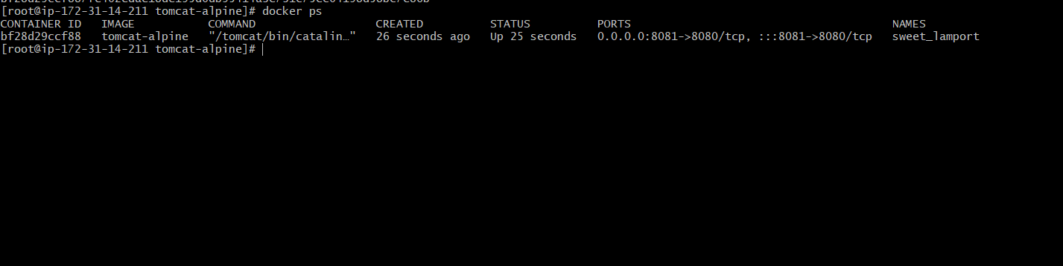

STEP 8: Access Tomcat
Open browser:
http://localhost:8080
You’ll see Tomcat page

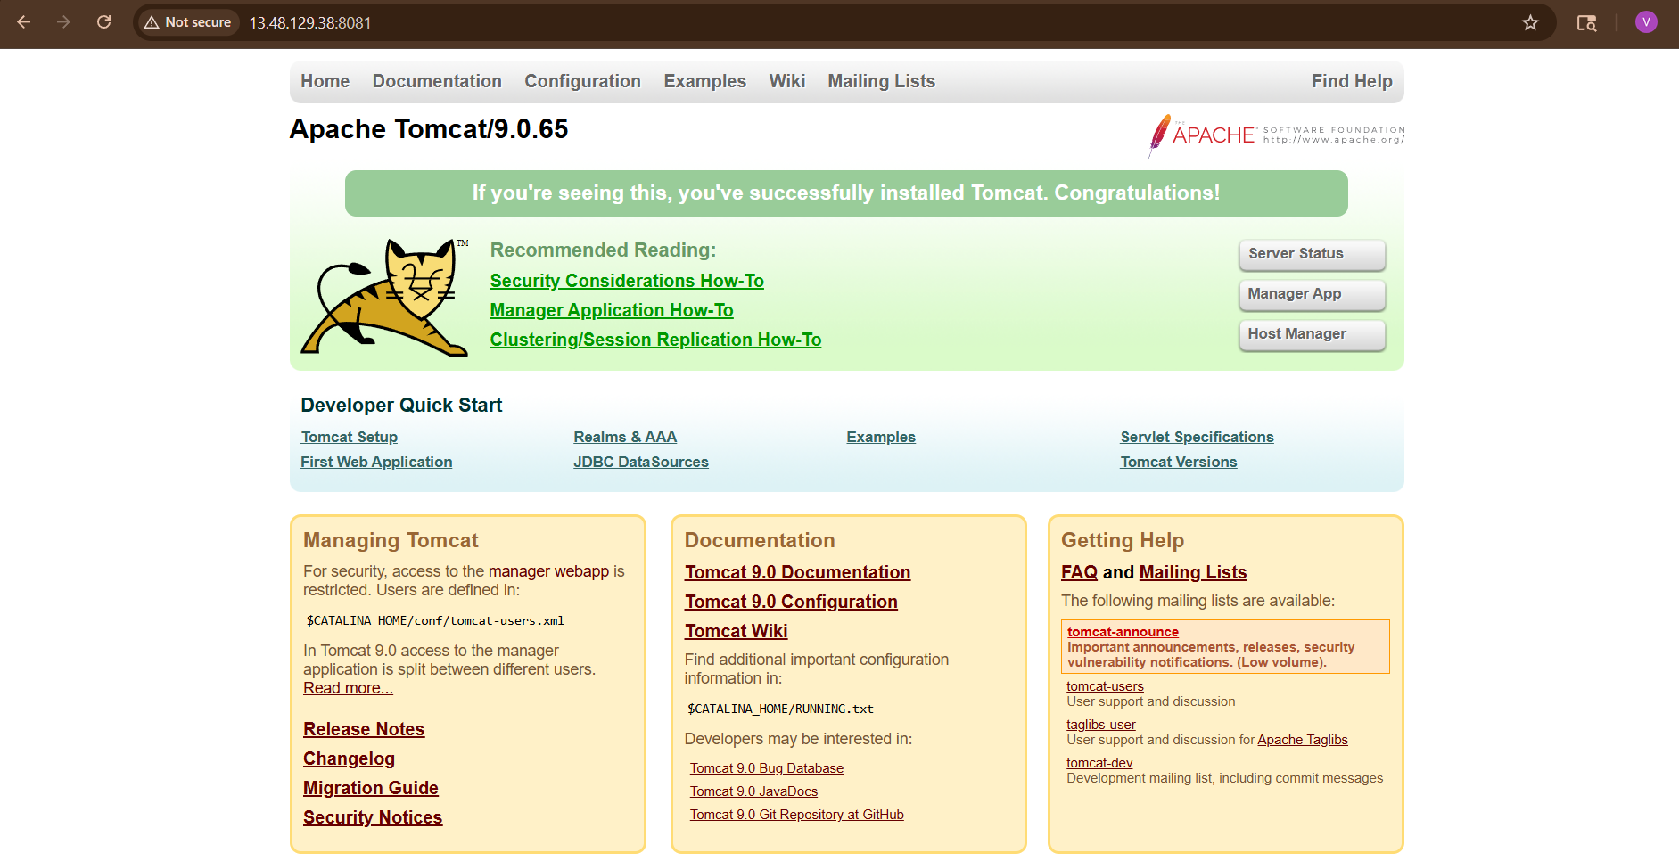

What You Achieved
✔ Created custom Docker image
✔ Installed Java inside container
✔ Installed Tomcat
✔ Ran web server

4) Create single stage and multi stage docker file using this source code: https://github.com/betawins/multi-stage-example.git
single stage docker file
STEP 1: Clone the Repository
git clone https://github.com/betawins/multi-stage-example.git
cd multi-stage-example
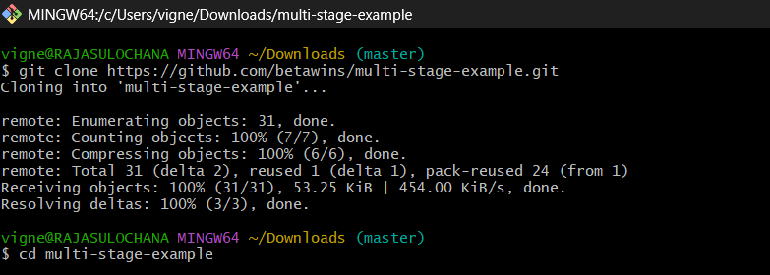

This project is a Java (Maven) application

STEP 2: Create Dockerfile
Inside the project folder:
vi Dockerfile
Paste this:
FROM maven:3.8.5-openjdk-17
WORKDIR /app
COPY . .
RUN mvn clean package
CMD sh -c "java -jar target/*.jar"

Save:
:wq
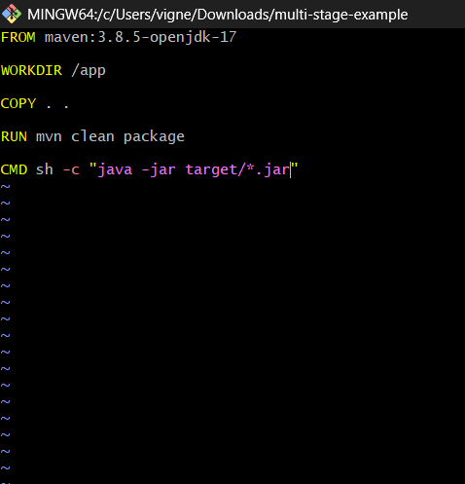

STEP 3: Understand It (Very Important)
- FROM maven... → contains Java + Maven
- WORKDIR /app → working directory inside container
- COPY . . → copies project files
- RUN mvn clean package → builds .jar
- CMD → runs application
Everything happens in ONE image (single-stage)

STEP 4: Build Docker Image
docker build -t single-stage-app1 .
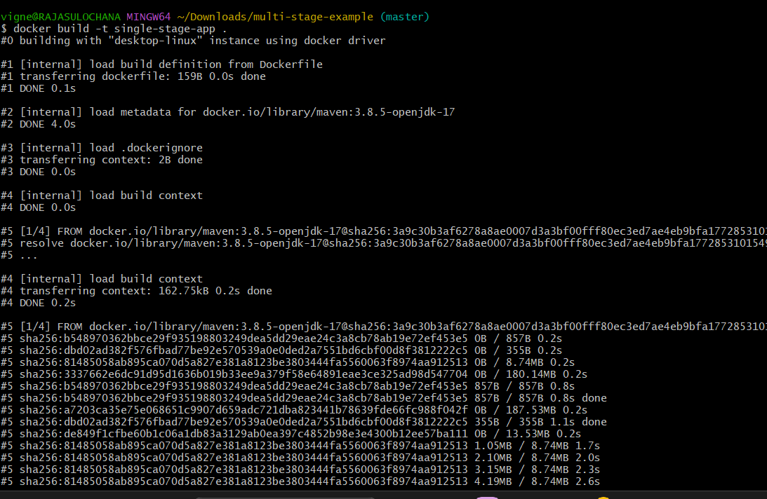


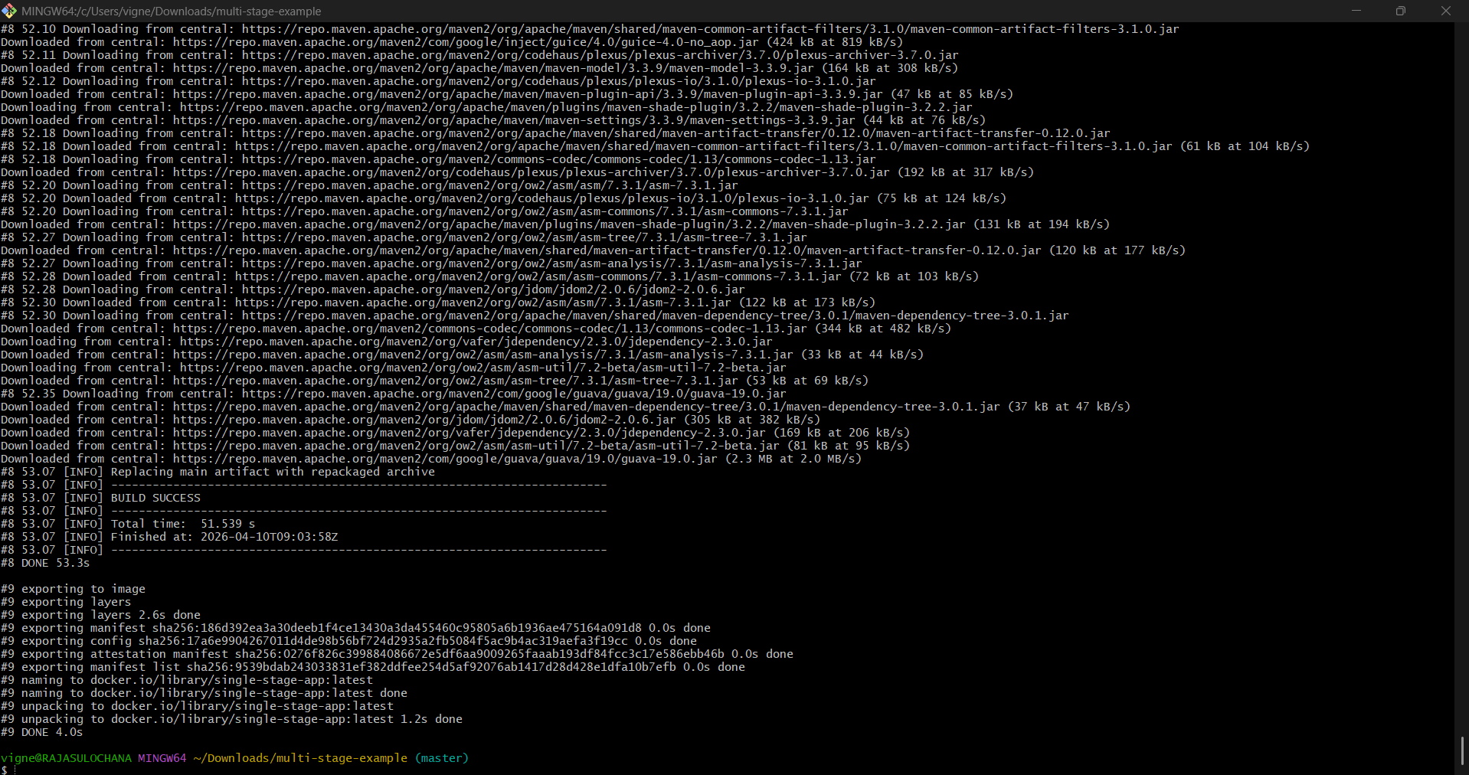

Output (Important part)
You’ll see:
BUILD SUCCESS
Means .jar file created in target/

STEP 5: Verify Image
docker images
You’ll see:
single-stage-app1 latest
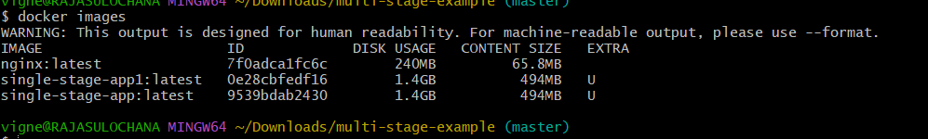

STEP 6: Run Container
docker run -d -p 8081:8080 single-stage-app1
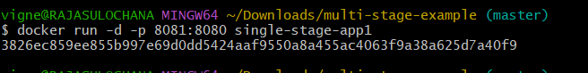

STEP 7: Check Running Container
docker -a
docker ps -a
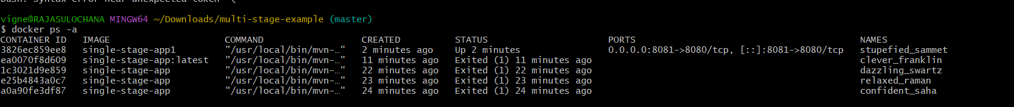
STEP 8: Access Application
Open:
http://<your-ip>:8080
If local:
http://localhost:8080

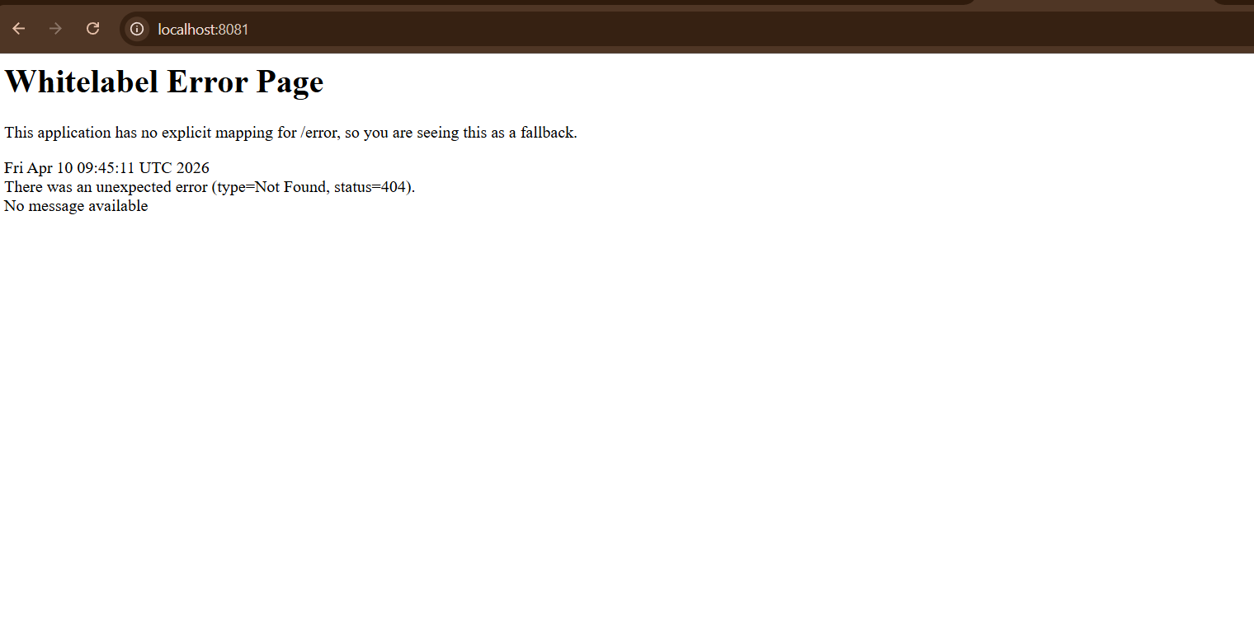

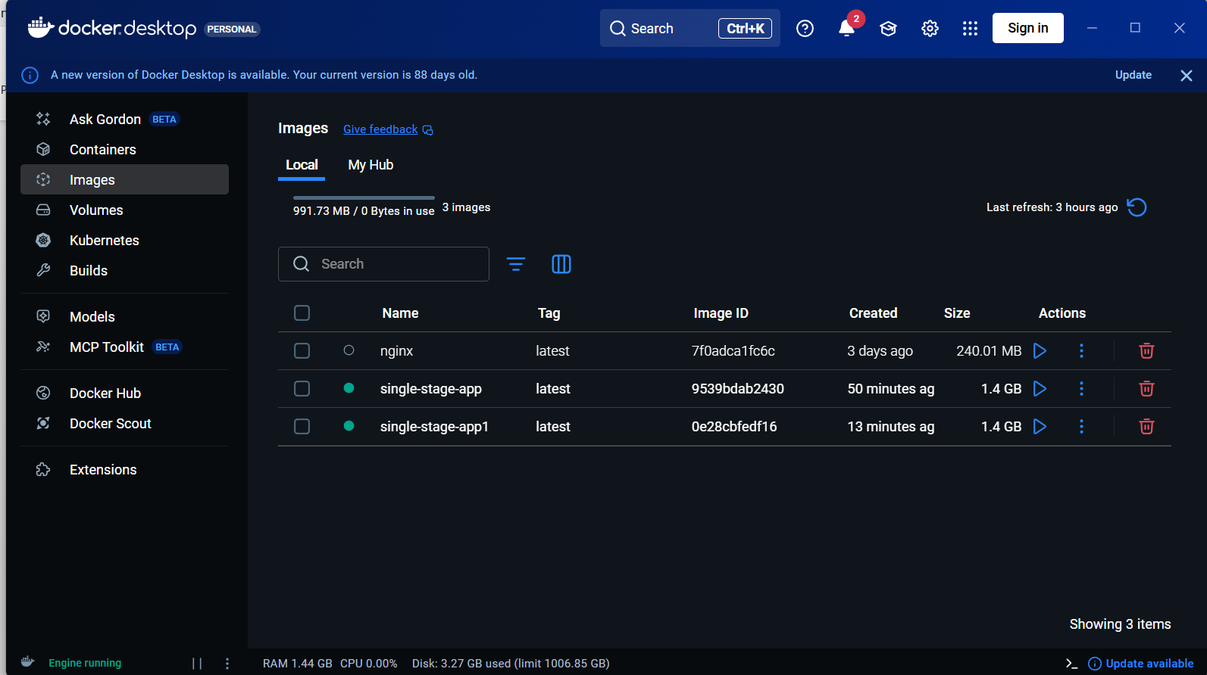

Multi-Stage Dockerfile

STEP 1: Go to project
git clone https://github.com/betawins/multi-stage-example.git
cd multi-stage-example

STEP 2: Create Dockerfile
vi Dockerfile

STEP 3: Paste Multi-Stage Dockerfile
# ---------- Stage 1: Build ----------
FROM maven:3.8.5-openjdk-17 AS builder
WORKDIR /app
COPY . .
RUN mvn clean package
# ---------- Stage 2: Runtime ----------
FROM eclipse-temurin:17-jdk-jammy
WORKDIR /app
COPY --from=builder /app/target/*.jar app.jar
CMD ["java", "-jar", "app.jar"]

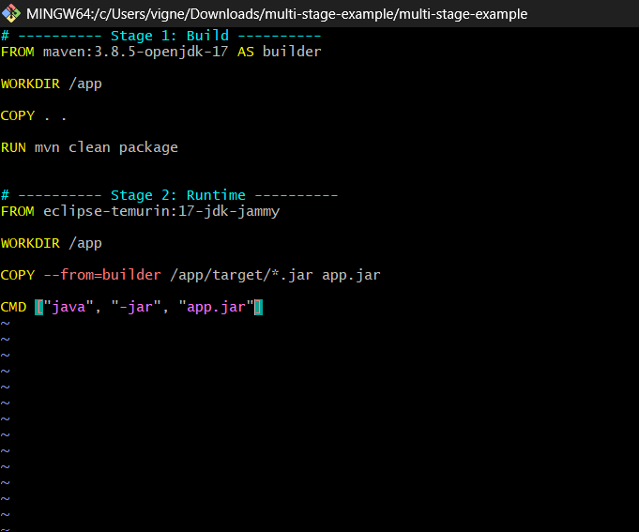

Save:
:wq
STEP 4: Understand (VERY IMPORTANT)
🔹 Stage 1 (builder)
- Uses Maven
- Builds .jar
🔹 Stage 2 (runtime)
- Uses lightweight image
- Copies only .jar
Removes:
- Maven ❌
- Source code ❌
- Dependencies ❌

STEP 5: Build Image
docker build -t multi-stage-app1 .
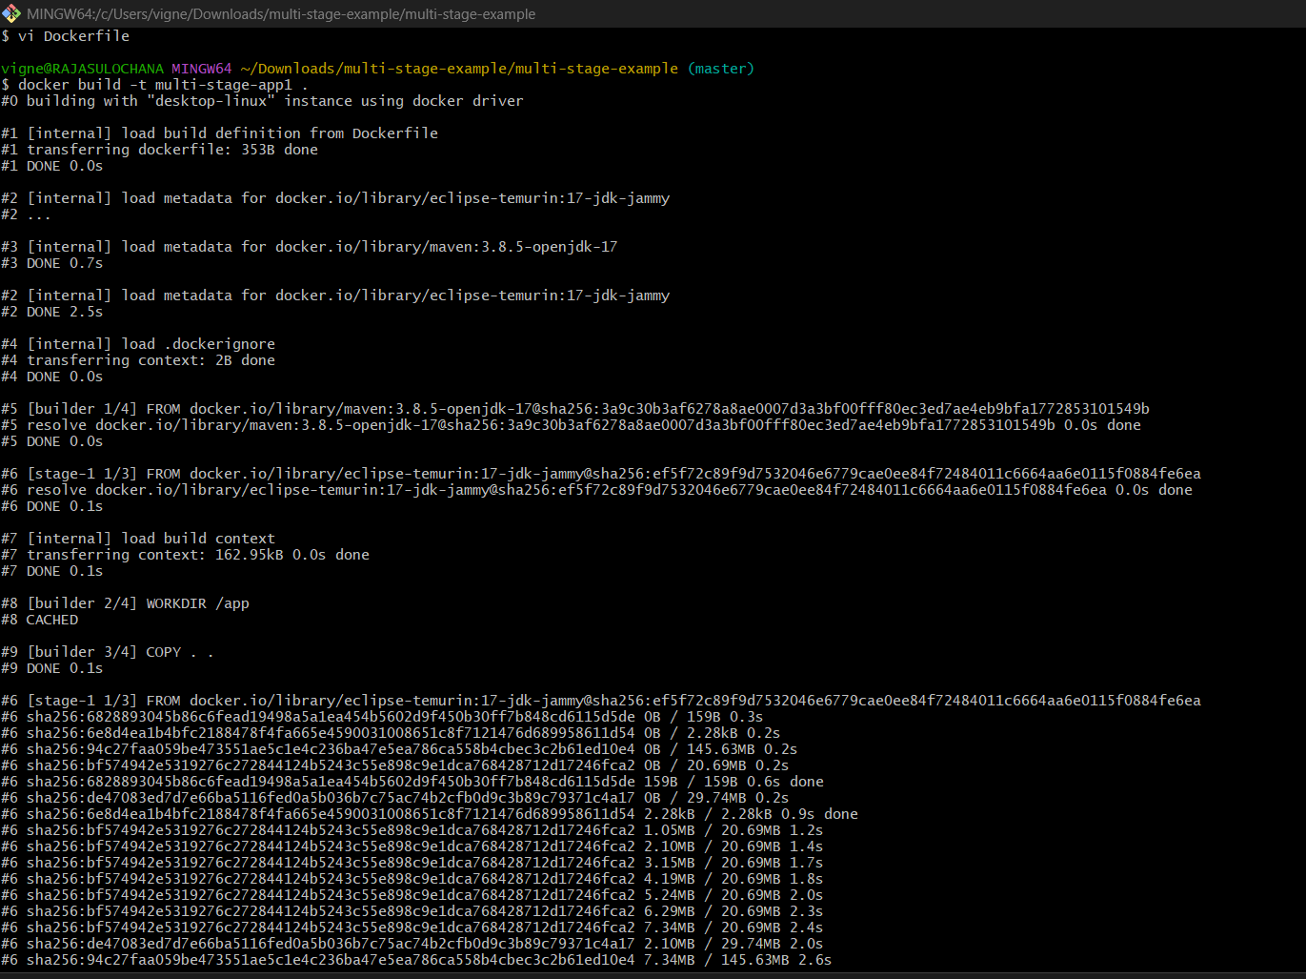

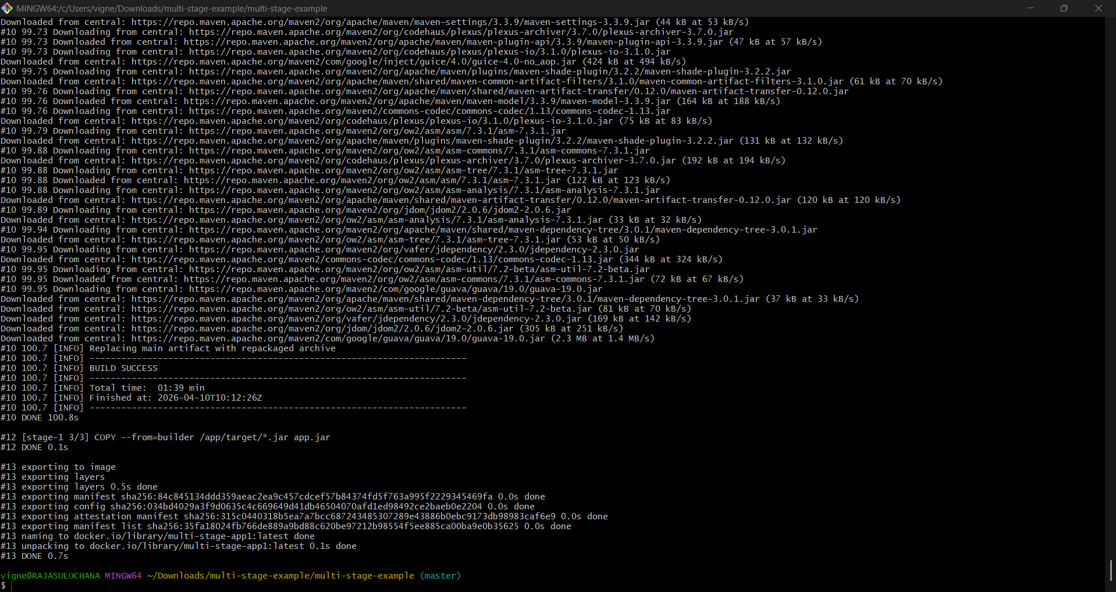

STEP 6: Check Image Size
docker images
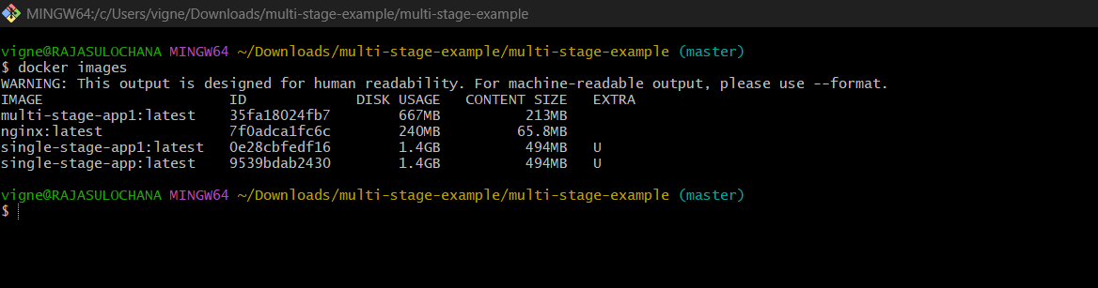

You’ll see:
multi-stage-app 667MB ✅
single-stage-app ~1.4GB ❌
🔥 Huge improvement!

STEP 7: Run Container
docker run -d -p 8085:8080 multi-stage-app
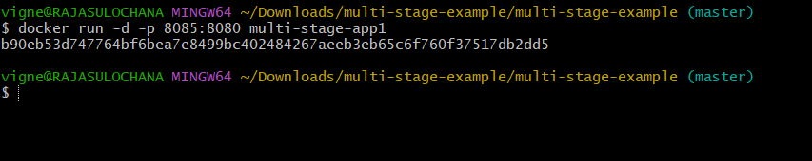

STEP 8: Verify Running
docker ps
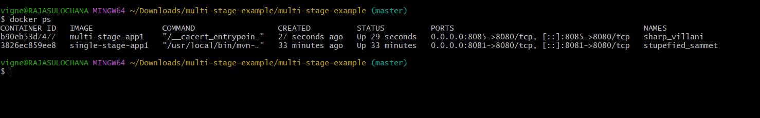

docker ps -a
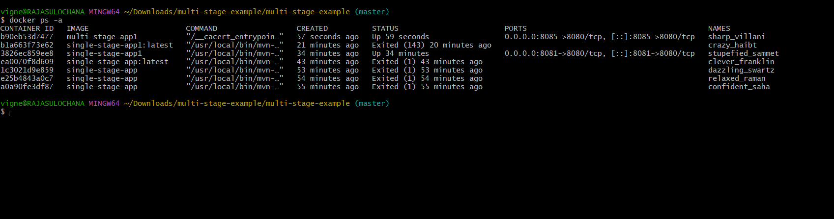

STEP 9: Access App
http://localhost:8085
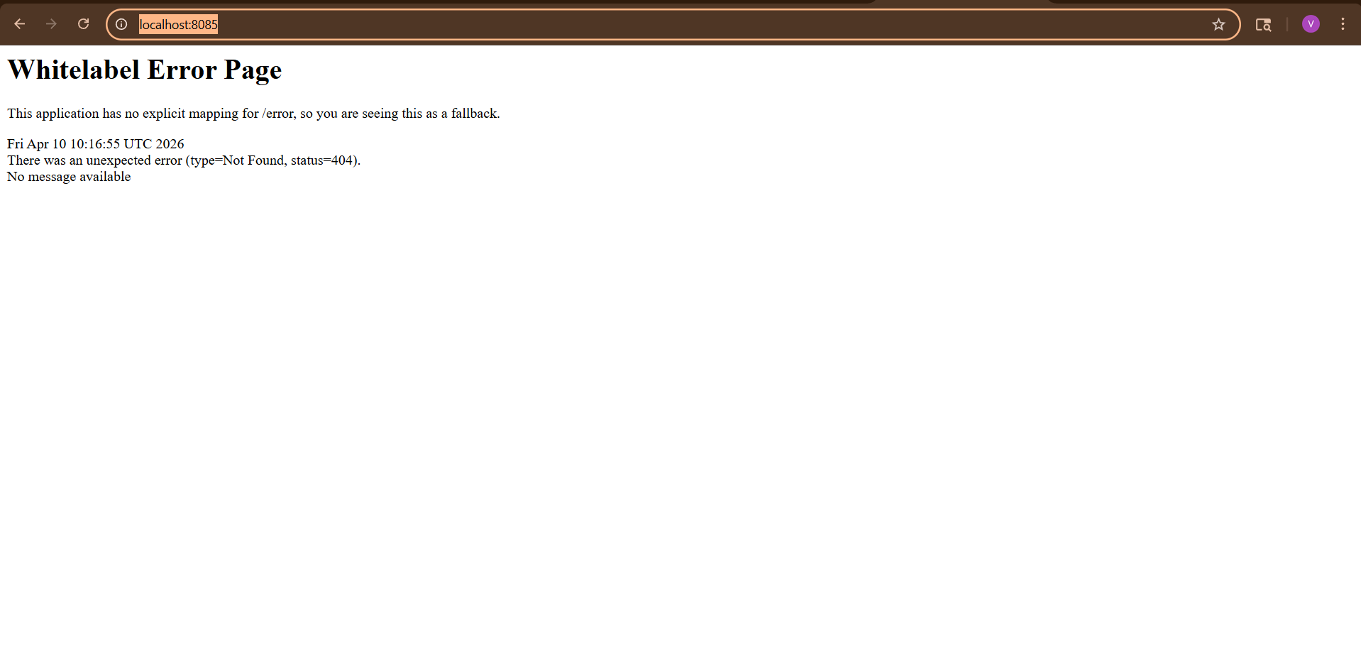
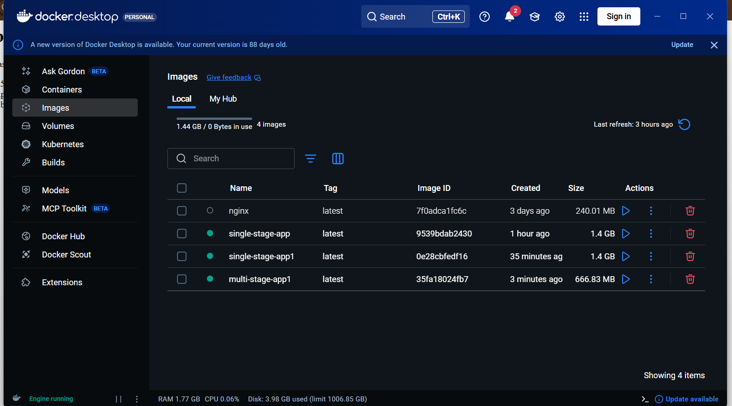

5) Install docker compose and execute sample application.

STEP 1: Install Docker Compose
👉 On Amazon Linux / Linux
sudo curl -L "https://github.com/docker/compose/releases/latest/download/docker-compose-$(uname -s)-$(uname -m)" -o /usr/local/bin/docker-compose

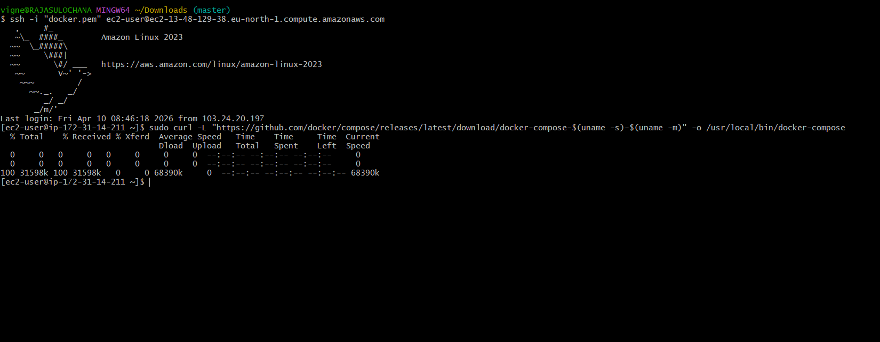

Give permission
sudo chmod +x /usr/local/bin/docker-compose

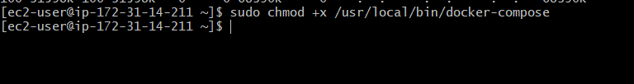

Verify installation
docker-compose –version
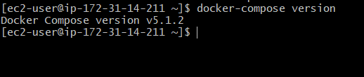

Output:
docker-compose version 2.x.x

STEP 2: Create Project Folder
mkdir compose-app
cd compose-app
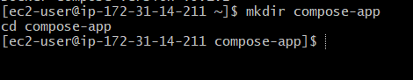

STEP 3: Create docker-compose.yml
vi docker-compose.yml
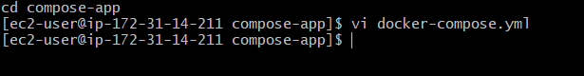

Paste this sample app (Nginx)

version: '3'
services:
web:
image: nginx
ports:
- "8084:80"

Save:
:wq

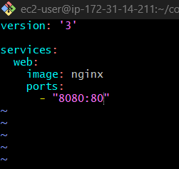
STEP 4: Run Application
docker-compose up -d
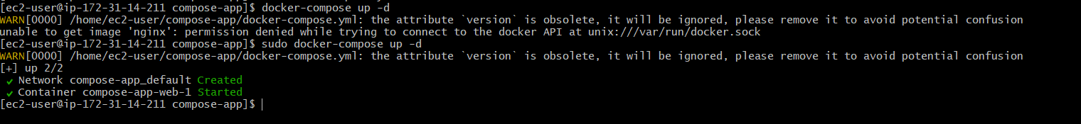

STEP 5: Verify
docker ps
You’ll see:
nginx Up 0.0.0.0:8080->80/tcp
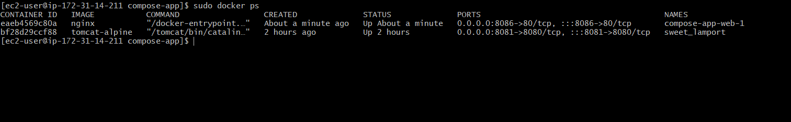

STEP 6: Access App
Open:
http://<your-ip>:8080
If local:
http://localhost:8080

Open browser:
http://localhost:8080
or
ip
http://13.48.129.38:8086

Nginx welcome page

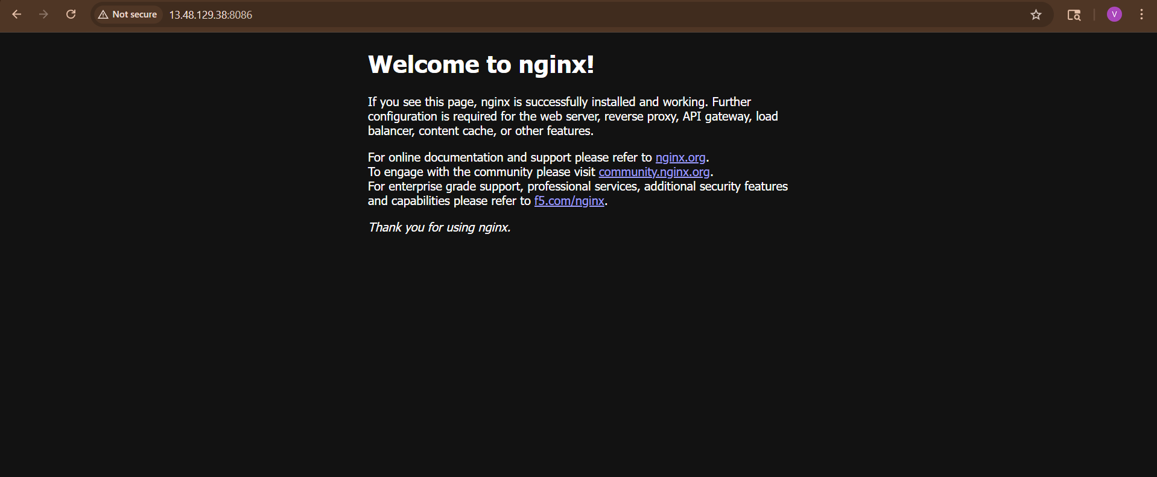

STEP 7: Stop Application
docker-compose down
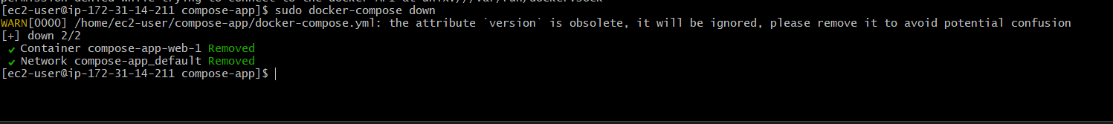

6) Implement solution to scan images when pushed to docker registry.

Step 1: Install Trivy
On Linux / EC2\
sudo yum install -y wget
wget https://raw.githubusercontent.com/aquasecurity/trivy/main/contrib/install.sh
sudo sh install.sh -b /usr/local/bin

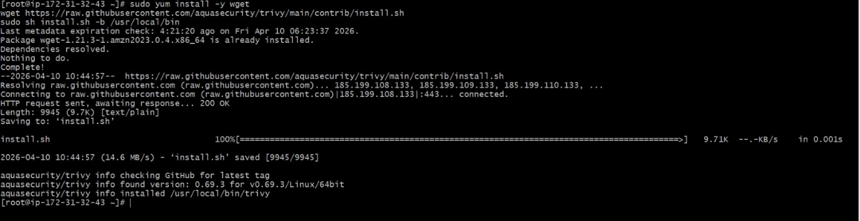

STEP 2: Verify Installation
trivy –version

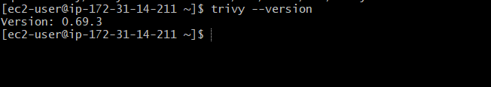

Output:
Version: x.x.x

STEP 3: Scan Docker Image
trivy image nginx

Output:
- HIGH vulnerabilities
- MEDIUM / LOW

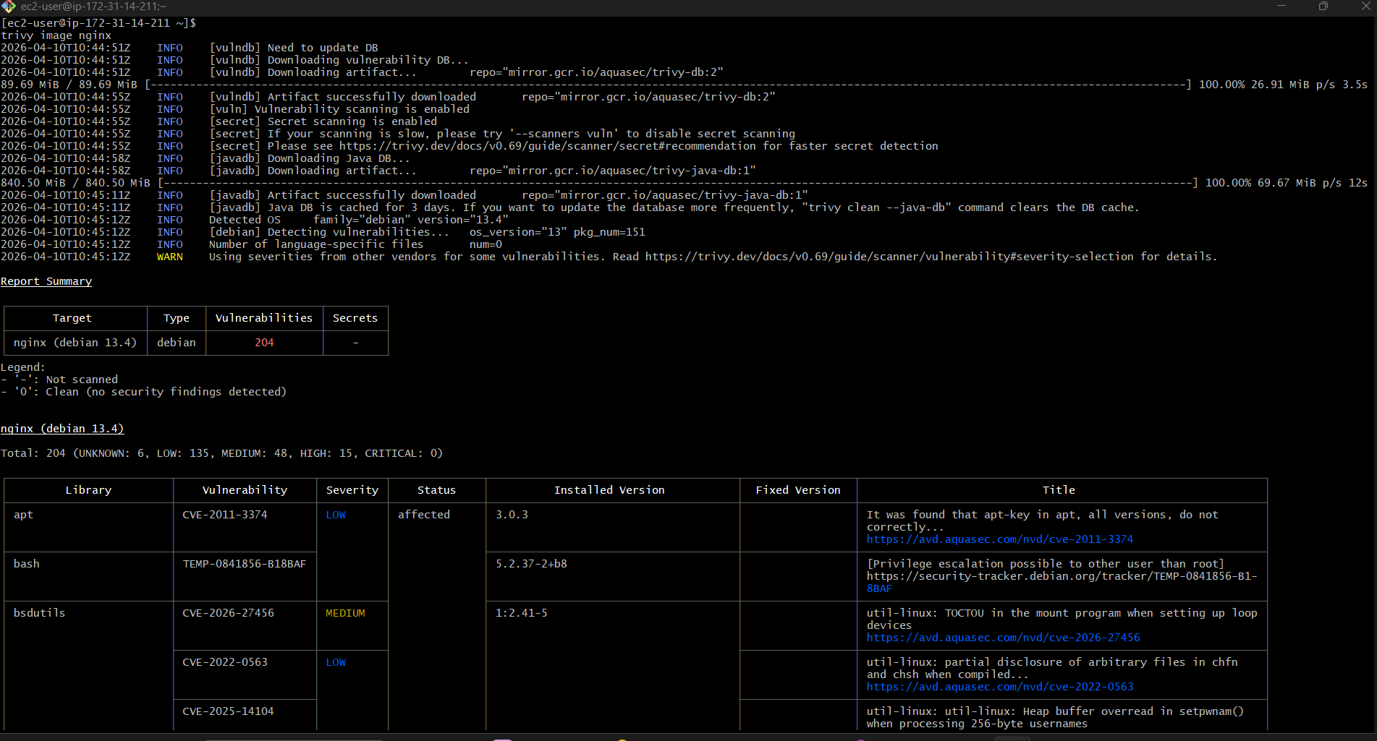

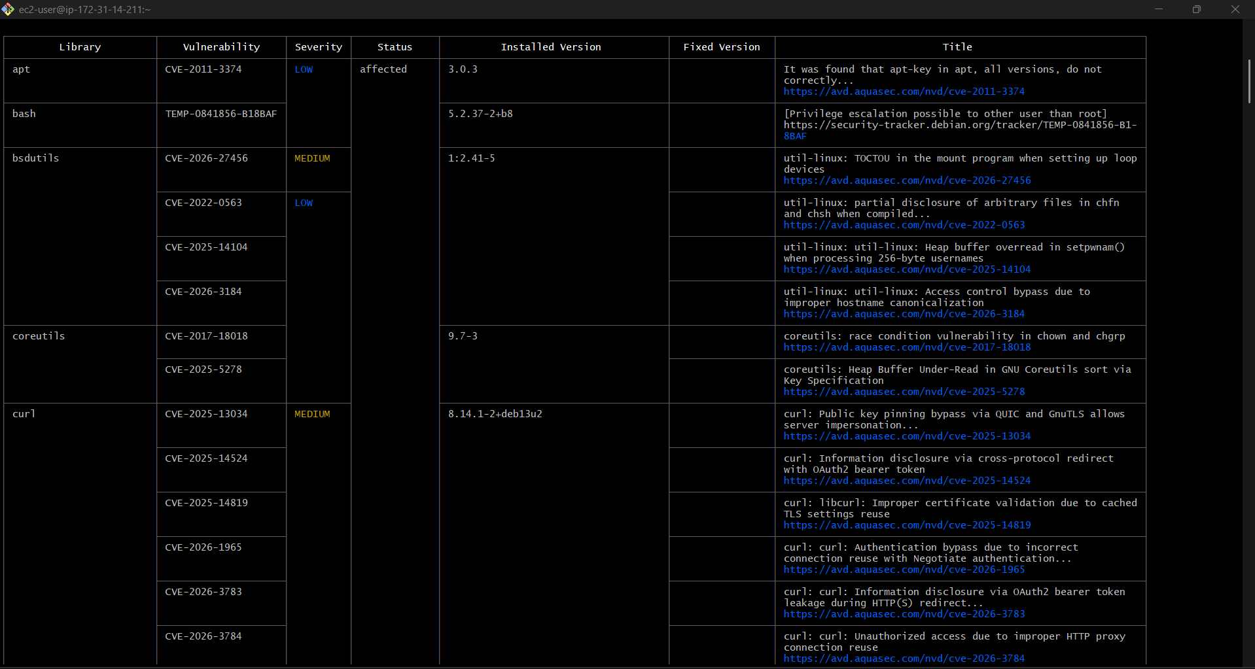

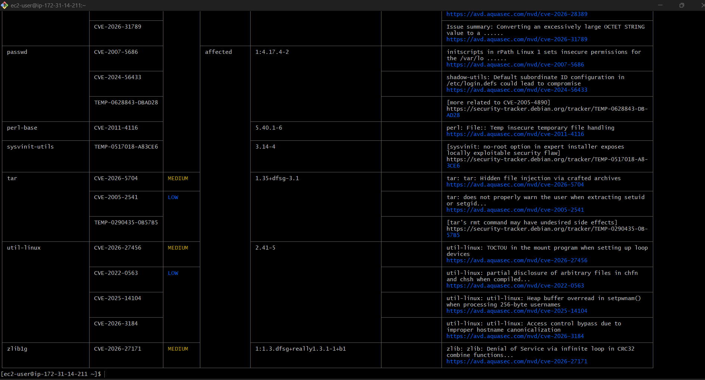

What You’ll See
- CRITICAL vulnerabilities
- HIGH / MEDIUM / LOW

7) Implement solution to scan images when pushed to AWS ECR.

STEP 1: Create ECR Repository with Scanning
aws ecr create-repository \
--repository-name myrepo \
--region eu-north-1 \
--image-scanning-configuration scanOnPush=true

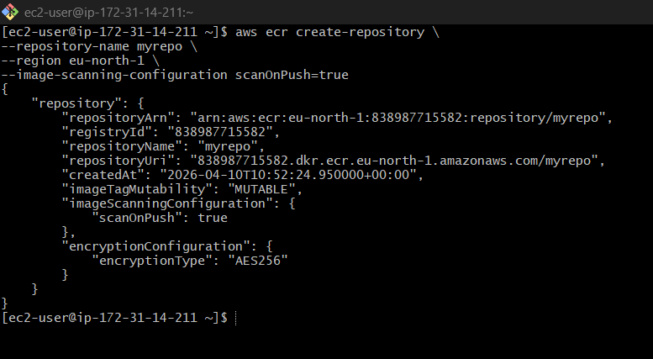

What this does
Enables:
Automatic vulnerability scanning on every push
STEP 2: Login to ECR
aws ecr get-login-password --region eu-north-1 \
| sudo docker login --username AWS --password-stdin 838987715582.dkr.ecr.eu-north-1.amazonaws.com
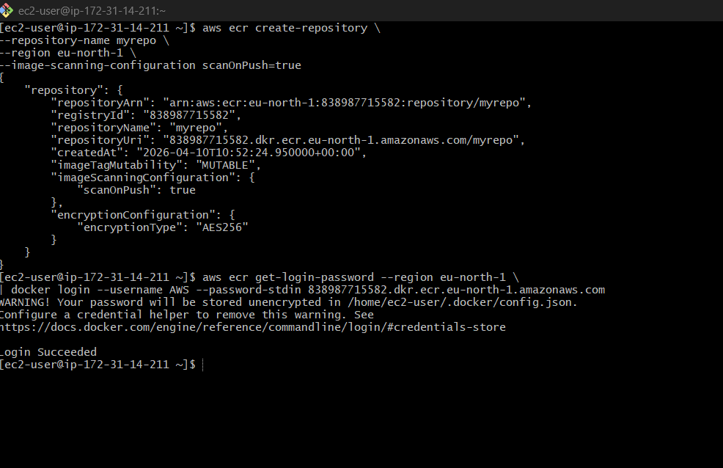
STEP 3: Tag Image
First check:
sudo docker images
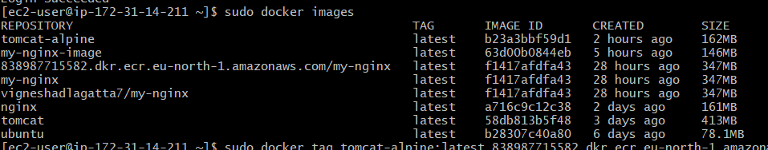
Then tag (replace image name if needed):
Replace <account-id> with your ID 838987715582
sudo docker tag myapp:latest 838987715587.dkr.ecr.eu-north-1.amazonaws.com/myrepo:latest

STEP 4: Push Image
sudo docker push 838987715582.dkr.ecr.eu-north-1.amazonaws.com/my-nginx:latest
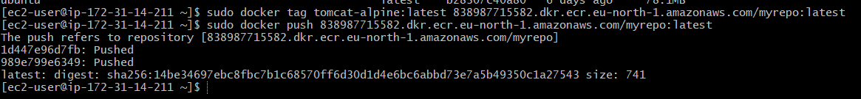
Expected Push Output
latest: digest: sha256:xxxxx size: xxxx
That means:
✔ Image pushed successfully
✔ ECR scan automatically started

STEP 5: Check Scan Results
Go to:
- AWS Console → ECR
- Open repository → Images
- Click image → Scan results tab
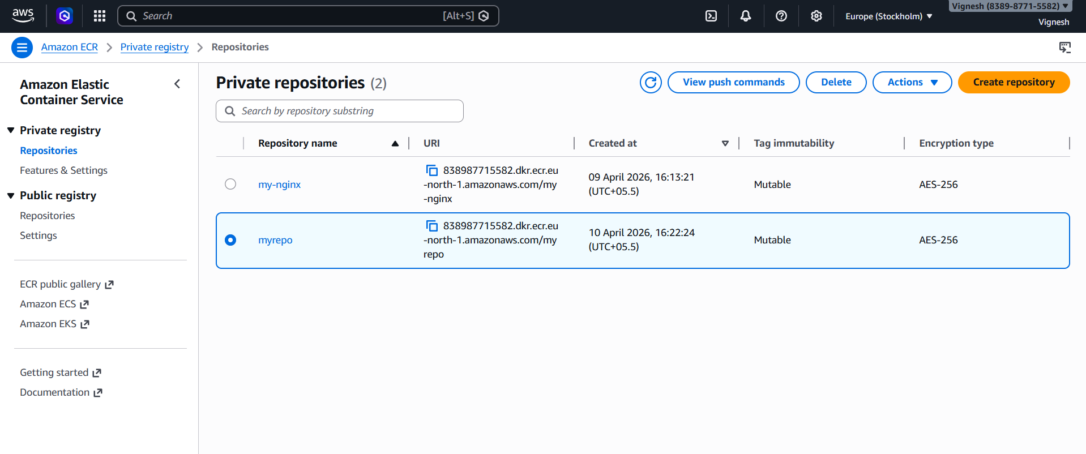
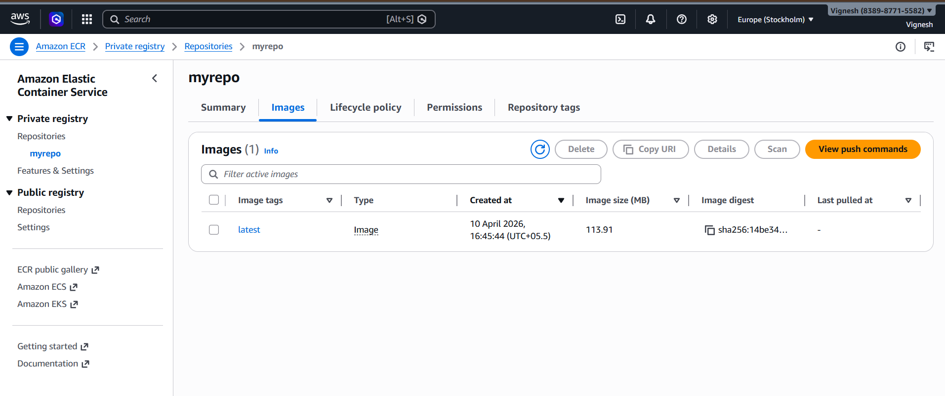
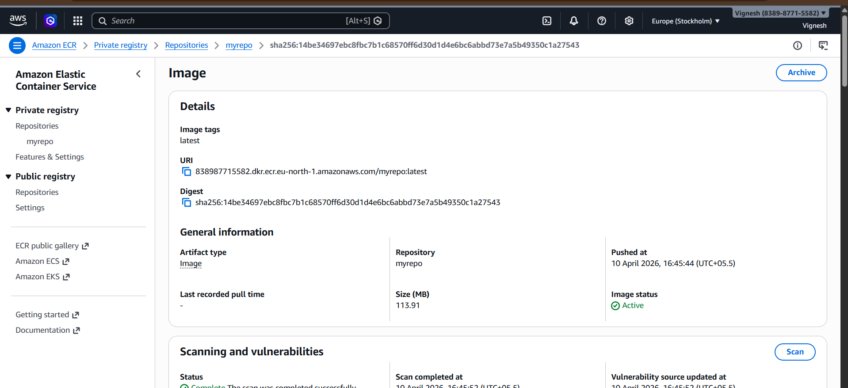

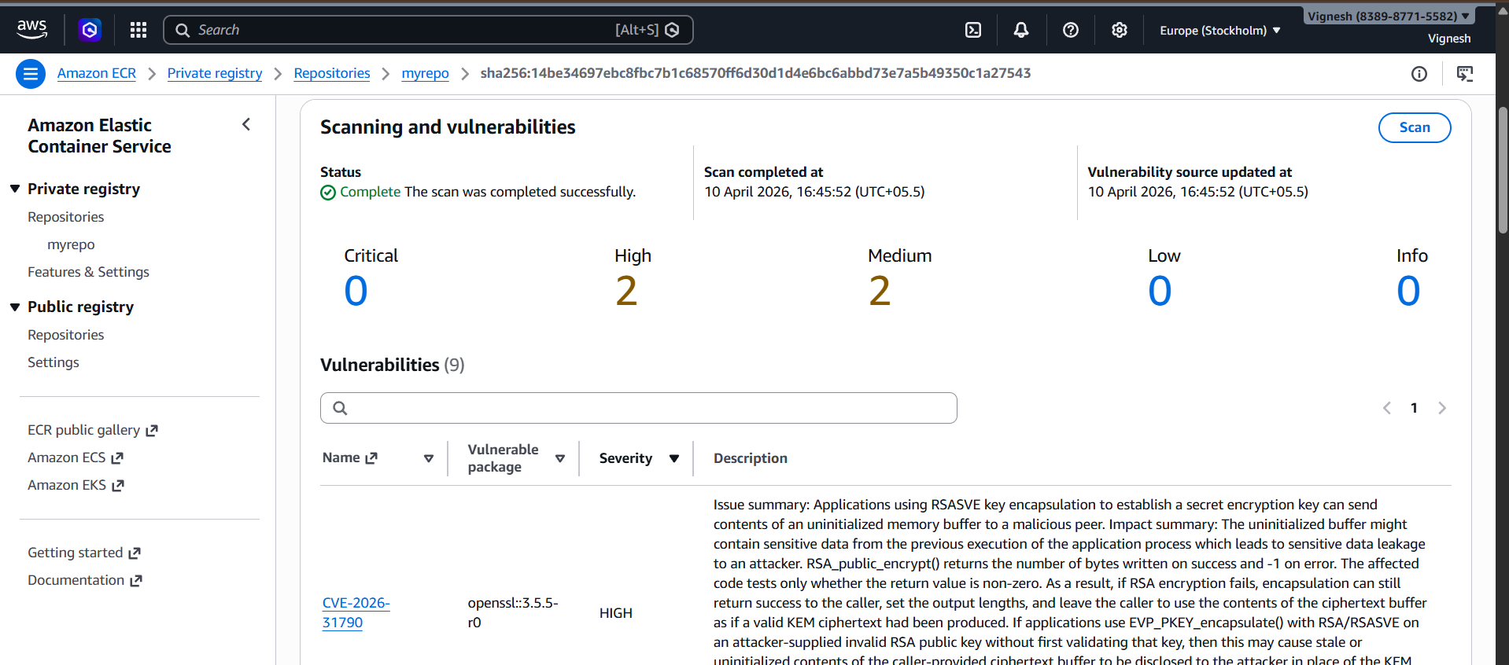

What you’ll see
- CRITICAL
- HIGH
- MEDIUM / LOW

WHAT YOU JUST DID 🔥
✔ Created Docker image
✔ Tagged for ECR
✔ Logged into AWS
✔ Pushed image
✔ Triggered vulnerability scan

8)Create a Jenkins pipeline to create a docker image and push the image to Docker hub.

PREREQUISITES
Make sure your Jenkins server has:
✔ Docker installed
✔ Jenkins running
✔ Docker Hub account
✔ Git repo (your project)

STEP 1: Add DockerHub Credentials in Jenkins
Go to Jenkins → Manage Jenkins → Credentials → Global → Add
- Kind: Username & Password
- Username: your DockerHub username
- Password: DockerHub password / token
- ID: docker-cred

STEP 2: Create Jenkins Pipeline Job
New Item → Pipeline → Name: docker-pipeline

STEP 3: Jenkinsfile
Paste this

pipeline {
agent any
environment {
IMAGE_NAME = "vigneshadlagatta7/my-nginx"
IMAGE_TAG = "latest"
}
stages {
stage('Clone Code') {
steps {
git 'https://github.com/betawins/multi-stage-example.git'
}
}
stage('Create Dockerfile (Java 17 Multi-Stage)') {
steps {
sh '''
cat > Dockerfile <<'EOF'
FROM maven:3.8.5-openjdk-17 AS builder
WORKDIR /app
COPY . .
RUN mvn clean package -DskipTests
FROM eclipse-temurin:17-jre-alpine
WORKDIR /app
COPY --from=builder /app/target/*.jar app.jar
EXPOSE 8080
ENTRYPOINT ["java","-jar","app.jar"]
EOF
cat Dockerfile
'''
}
}
stage('Build Docker Image') {
steps {
sh 'docker build -t ${IMAGE_NAME}:${IMAGE_TAG} .'
}
}
stage('Login to DockerHub') {
steps {
withCredentials([usernamePassword(
credentialsId: 'docker-cred',
usernameVariable: 'DOCKER_USER',
passwordVariable: 'DOCKER_PASS'
)]) {
sh 'echo ${DOCKER_PASS} | docker login -u ${DOCKER_USER} --password-stdin'
}
}
}
stage('Push Image') {
steps {
sh 'docker push ${IMAGE_NAME}:${IMAGE_TAG}'
}
}
}
post {
success {
echo '✅ Docker image built and pushed successfully'
}
failure {
echo '❌ Pipeline failed'
}
}
}
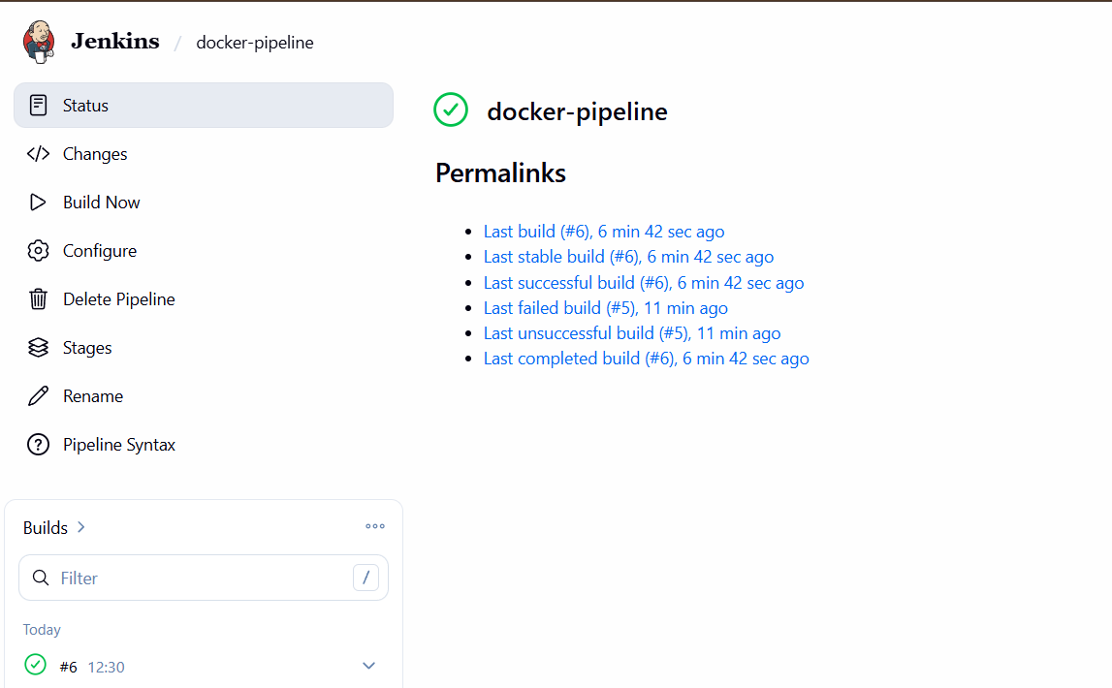
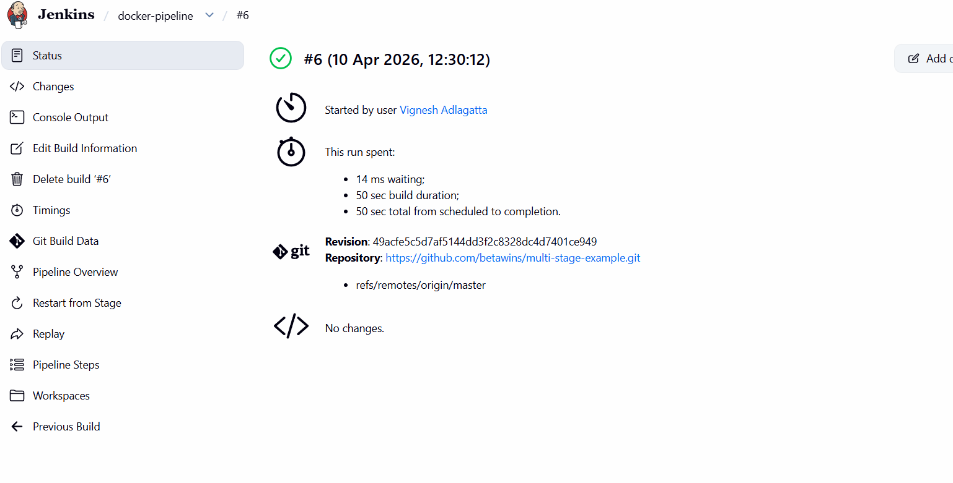
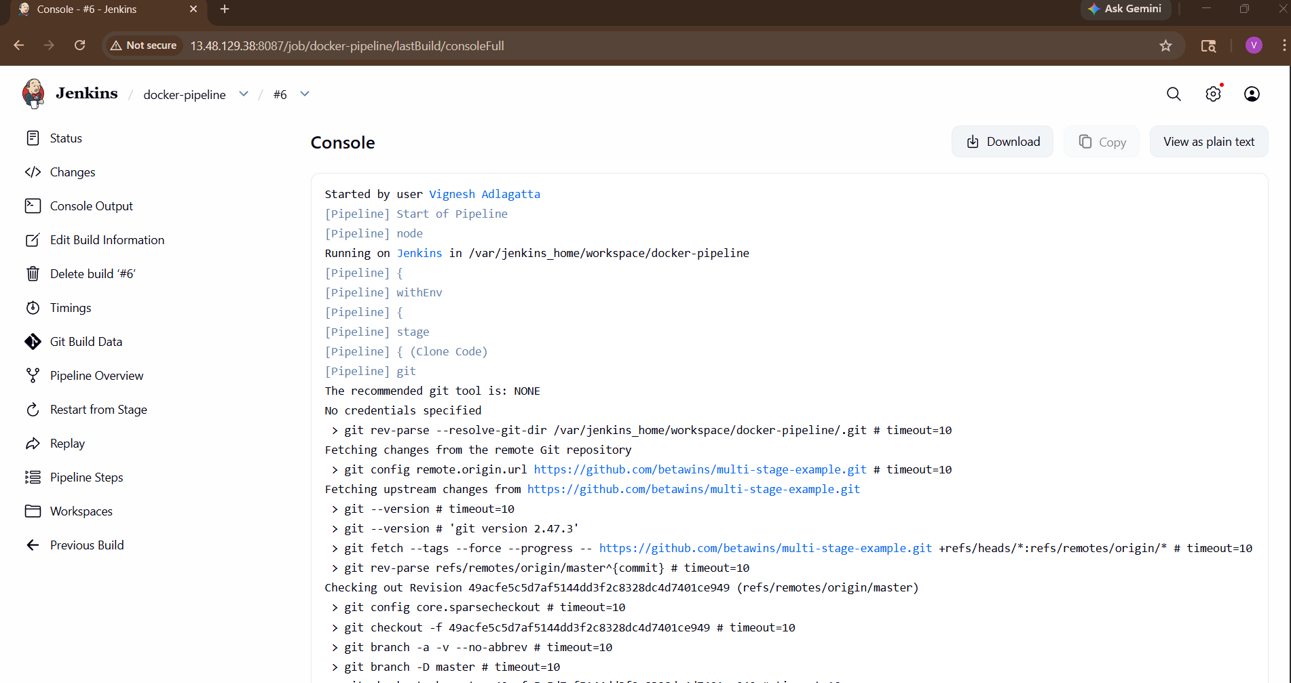
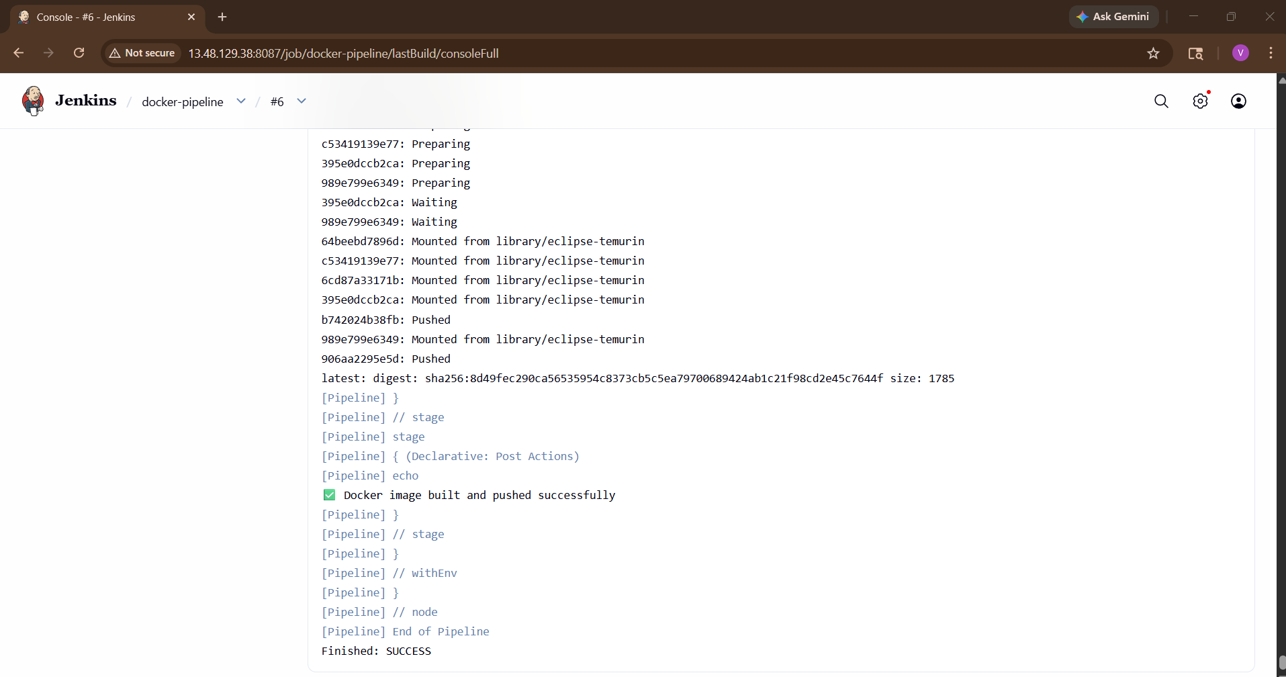
EXPLANATION
🔹 Clone Stage
Pulls your project from GitHub

🔹 Build Stage
Creates Docker image:
vigneshadlagatta7/my-nginx

🔹 Login Stage
Secure login using Jenkins credentials

🔹 Push Stage
Uploads image to Docker Hub

STEP 4: Run Pipeline
Click Build Now

EXPECTED RESULT
In console:
Successfully built image
Pushed to Docker Hub

VERIFY
Go to Docker Hub:
- Docker Hub
- Check repository → image visible ✅
